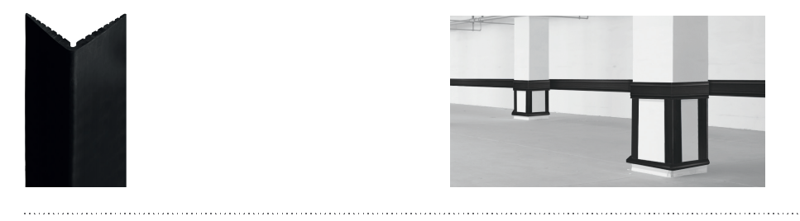


SPECIFICATION

ELASTO’FLEX 100V
VARIABLE ANGLE CORNER PROTECTOR
- Description: variable angle corner protector (from 45° to 135°) in non-rigid and smooth thermoplastic elastomer, 100 mm wing width (external measurement) / 90 mm wing width (internal measurement) (Elasto’Flex 100V as manufactured by SPM) comprising a profile, from 4 mm (end) to 10 mm (corner), solid colour, giving it excellent impact-resistance properties and good ageing and UV resistance.
- Environment: no heavy metals are used in its formulation, nor PBT/BPA. 100% of the product are recyclable.
- Colour: black.
- Installation method: by screwing.

